Submitted by-

Name- Ishan Rawat

SAP ID- 500087524

Roll no- R2142201888

Application Containerization and Orchestration Lab

# Experiment –3

AIM: Working with Docker Volume

Steps:

1. View all Volume in Docker

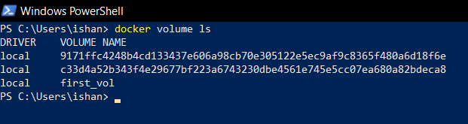

1. Create a new Volume

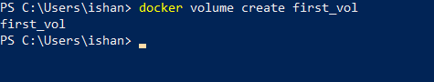

1. Mount a Volume with a container

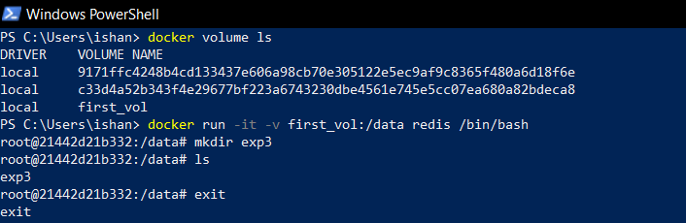

1. Create another container and Mount with the same Volume

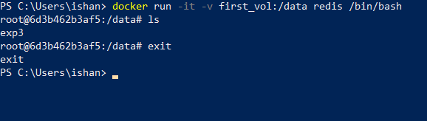

1. See the complete working of container

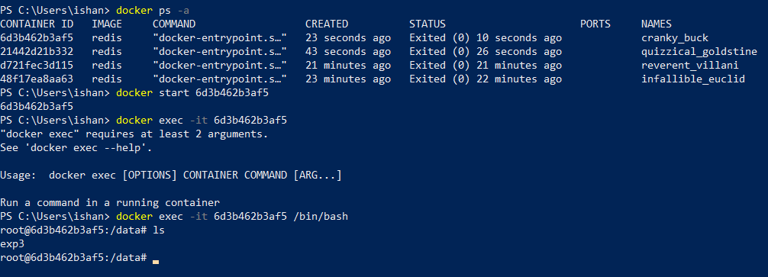

1. Exited from container and restart again to see the persistent of Docker Volume

